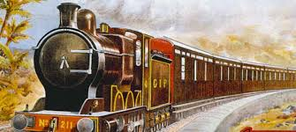

**Project Title**

|  |
| --- |
| RAILWAY RESERVATION SYSTEM |



Why we build this project?

It is easy to handle and it consume less time for registration when customer comes.It gives us benefit in many ways like, it store each entry automatically. We don’t need to spend our time in writing all information about customer.

The purpose of this software is to describe the Railway Reservation System which provides the rail timing details, reservation, enquiry, billing and cancellation on various types of reservation namely:-

•

Confirm reservation for confirm seat

•

Reservation against cancellation

•

PNR generation

• Scope of the Project in the Industry:

The scope of this project is limited to an engineering college. This project aims to maintain passenger and train information.Other scopes of this project are as follows:

•

Freight Revenue enhancement

•

Passenger Revenue enhancement

•

Improved and optimised service

**OVERVIEW:**

This project aims at development of a Railway Reservation System that facilitates the Railway customers to manage their reservations and the Railway administrators to modify the backend databases in a User-Friendly manner. This project includes the following functions:

1) Create new database.

2) Add new Record

3) Modify

4) Display record

5) Ticket reservation

6) Ticket Modification

7) Ticket Cancellation

8) Ticket printing

**SEQUENCE DIAGRAM**

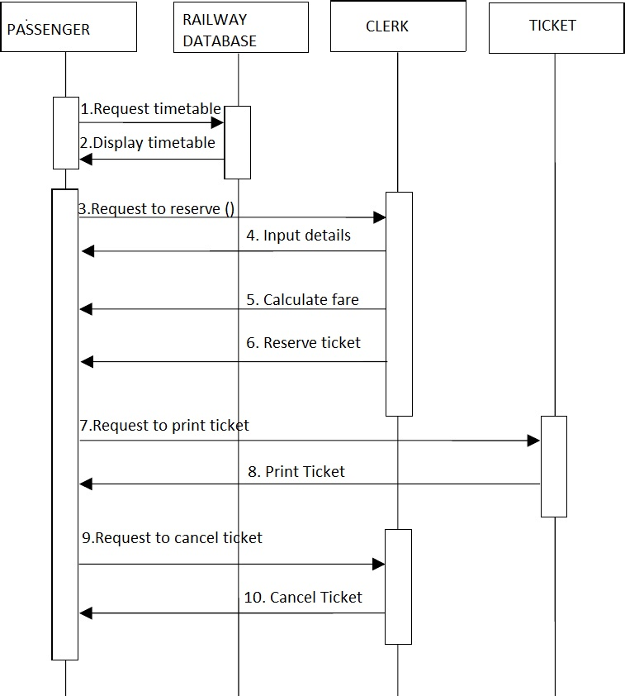

Flow Chart

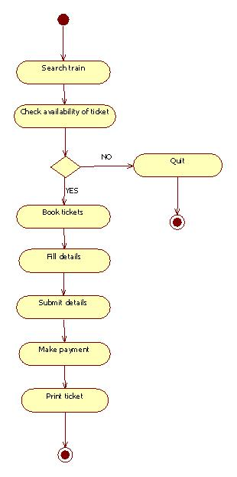

Header Files

There are two Header files used in this Project:

.include<iostream>

.include<conio.h>

Operators

There are many operators used in it:

.If Else

.Switch

.Array

.Pointer

.String

.Structure

.Functions

Code

#include<iostream>

#include<conio.h>

using namespace std;

void main()

{

char ch;

do //Use Of Do While

{

system("color 1f");

{int i, j;

char arr[7][21];

for(i = 0; i<7; i++)

{ for (j = 0; j<21; j++)

{ arr[i][j] = ' '; } // Use of Array

}

arr[0][1] = '*';

arr[0][2] = '*';

arr[0][3] = '*';

arr[0][7] = '*';

arr[0][8] = '*';

arr[0][9] = '*';

arr[0][12] = '*';

arr[0][13] = '*';

arr[1][2] = '*';

arr[1][6] = '*';

arr[1][14] = '*';

arr[2][2] = '*';

arr[2][6] = '*';

arr[2][12] = '*';

arr[2][14] = '*';

arr[3][2] = '*';

arr[3][6] = '*';

arr[3][12] = '*';

arr[3][13] = '*';

arr[4][2] = '*';

arr[4][6] = '*';

arr[4][12] = '*';

arr[5][2] = '*';

arr[5][6] = '*';

arr[5][12] = '*';

arr[6][1] = '*';

arr[6][2] = '*';

arr[6][3] = '*';

arr[6][7] = '*';

arr[6][8] = '*';

arr[6][9] = '*';

arr[6][12] = '*';

for (i = 0; i<7; i++)

{ cout << endl;

for (j = 0; j<21; j++)

{ cout << " ";

cout << arr[i][j];

}

}

cout << endl;

cout << endl;

cout << endl;

}

cout<<"--------------------------------------------------------------------------------\n";

cout<<"--------------------------------------------------------------------------------\n";

cout<<"---------------------------WELCOME TO RAILWAY STATION---------------------------\n";

cout<<"--------------------------------------------------------------------------------\n";

cout<<"--------------------------------------------------------------------------------\n";

int b,c,d,price=0,x=0;char name[50];char cnic[25];

char str1[10]="SAHIWAL"; //Use of String

char str2[10]="LAHORE";

char str3[10]="KARACHI";

char str4[10]="MULTAN";

char city[10]="";

cout<<"Enter The Name Of Customer:\n";

cin.getline(name,50);

cout<<"Enter The CNIC Number of Customer:\n";

cin.getline(cnic,25);

system("cls");

system("color 5f");

cout <<"\nSir,In Which City You Want To Travel:\n"<<endl;

cout <<"Press 1 For SAHIWAL And Price is 250."<<endl;

cout <<"Press 2 For LAHORE And price is 350."<<endl;

cout <<"Press 3 For KARACHI And price is 450."<<endl;

cout <<"Press 4 For MULTAN And Price is 550."<<endl;

cin>>x;

if (0<x<5)

{

if (x==1)

{ strcpy(city,str1); //Use Of String

price=250;

}

if (x==2)

{ strcpy(city,str2);

price=350;

}

if (x==3)

{ strcpy(city,str3);

price=450;

}

if (x==4)

{ strcpy(city,str4);

price=550;

}

}

system("cls");

system("color 5b");

cout<<"You Have Selected:"<<city<<endl;

cout<<"\nThere are 4 timing of Trains for "<<city<<":\n";

cout<<"Press 1 for the Train which will departure for "<<city<<" at 9am.\n";

cout<<"Press 2 for the Train which will departure for "<<city<<" at 12pm.\n";

cout<<"Press 3 for the Train which will departure for "<<city<<" at 3pm.\n";

cout<<"Press 4 for the Train which will departure for "<<city<<" at 6pm.\n";

cin>>d;

if(d>=1&&d<=4);

{

cout<<"\nHow Many Seats Do You Required:"<<endl;

int n,*ptr;cin>>n;

int arr[100];

ptr = arr;

int xy=0;

system("cls");

system("color 4b");

cout << "Your Trian Is For " << city<<endl;

cout<<"\nYour Seat Numbers Are "<< endl;

{ for (int i = 0; i <n; ++i)

{ cout << "Your seat number is: "<< ptr + i << endl; //Use Of pointers

xy++;}

}

int p,m,t,k=100,l=0;

p=price*xy;

cout<<"\nYour Total Price is:";

cout <<p;

cout <<"\n\nThe Price of One Mess is 100.\nFor How Many Persons Do You Want Mess:";

cin>>m;

l=m*k;

t=l+p;

cout<<"\nYour Total Bill Is :"<<t;

cout<<endl;

system("cls");

system("color 0f");

cout<<"\n\nNAME\t\tCNIC\t\t\tCITY\t\tTOTAL\n";

cout<<name<<"\t"<<cnic<<"\t\t"<<city<<"\t\t"<<t;

cout<<endl;

cout<<endl;

cout<<"-------------------------------------------------------------------------------\n";

cout<<"-------------------------------------------------------------------------------\n";

cout<<"----------------------------ThankYou For Coming Sir----------------------------\n";

cout<<"-------------------------------------------------------------------------------\n";

cout<<"-------------------------------------------------------------------------------\n\n\n";}

cout<<"You Want To Continue OR Not:";

cout<<"\nPress Y or y For Continue And N or n For Discard:";

cin>>ch;}

while(ch=='Y'||ch=='y');

getch();}